1.0 | OBJECTIVE : | To describe the validation procedure for Pharmasuite (ERP).
2.0 | SCOPE : | This procedure is applicable for validation of pharmasuite software installed in the computer of Administrator of the Pharmasuite (ERP) at Indiana Ophthalmics LLP.
3.0 | RESPONSIBILITY : | Administrator of Pharmasuite (ERP) / All Department Head / All Users of Pharmasuite
4.0 | ACCOUNTABILITY : | QA Head / Administrator of Pharmasuite (ERP)
5.0 | PROCEDURE :
5.1 | This procedure describes general validation concepts and practices including the way processes and systems of the Pharmasuite (ERP) shall be qualified and validated.
5.2 | Validation of the Pharmasuite (ERP) shall be carried out by External Validation Agency / validation consulting team.
5.3 | The written agreement between Indiana Ophthalmics LLP and Validation External Agency shall be available.
5.4 | The following typical areas shall be covered while validating the Pharmasuite (ERP):-
5.4.1 | Pharmasuite (ERP) Hardware and Software :-
5.4.1.1 | ERP Server Hardware Configuration
5.4.1.2 | Software of the Server System includes following :-
- Operating system installation and configuration of server system.
- ERP application software installation and configuration.
- Documents procedure and manual of the installed ERP server system.
- Administration and access control configuration of server system.
5.4.2 | ERP (Pharmasuite Software) Application Software :-
5.4.2.1 | The following modules shall be included during validation of application software.
- QA
- QC
- Production
- Warehouse
- Purchase
- Sales
5.5 | If there is a need of incorporating of any new application system, the same shall be validated prior to usage.
5.6 | The following validation documents, but not limited to, shall be provided by the external validation agency :-
- Validation Plan
- User Requirement Specification
- Design Qualification
- Risk Assessment
- Installation Qualification Protocol cum Report
- Operation Qualification Protocol cum Report
- Performance Qualification protocol cum Report
- Requirement Traceability Matrix
- Validation Summary Report
5.6.1 | Validation Plan :-
5.6.1.1 | Validation plan shall include prior review from the responsible personnel of Indiana Ophthalmics LLP and prior approval from the QA Head. It shall include the Validation approach including sequential steps of validation activity alongwith all test to be performed while validating the Pharmasuite (ERP).
5.6.2 | Risk Assessment :-
5.6.2.1 | Validation activity shall include Risk identification and quantitative evaluation for individual GxP Process.
5.6.2.2 | Current control measures and required mitigations need to be identified for individual possible risk / failure to minimize risk during the validation activity. This will direct the qualification effort in the focused way.
5.6.3 | Installation Qualification :-
5.6.3.1 | The Installation Qualification shall include server, client, hardware and operating programs with utilities.
5.6.3.2 | This shall be carried out to ensure that system applications operate as per acceptance criteria described in IQ and to ensure that components that make up the technical infrastructure meets the system requirements and are completely & properly installed in the required environment.
5.6.3.3 | The installation qualification activity shall also include identification of live database.
5.6.4 | Operation Qualification :-
5.6.4.1 | The Operation Qualification shall consist of testing of information flows in terms of individual process. These tests shall be carried on live database. All the tests of the Operation Qualification shall be performed on the identical test database of the live system. Positive and Negative challenge test shall be done in the test server.
5.6.5 | Performance Qualification :-
5.6.5.1 | The Performance Qualification shall consist of the Integration and Process flow verifications which describes the inter relationship between all modules, systems and procedural controls. The Performance Qualification shall be performed on live server.
5.6.6 | Validation Summary Report :-
5.6.6.1 | After completion of the validation activity, Validation summary report shall be provided by the external validation agency which shall include test objectives and its results.
5.6.6.2 | At the conclusion of the qualification activity, Pharmasuite (ERP) validation summary report shall be generated summarizing the activities performed, any deviations from the plan, any outstanding corrective actions, and providing a statement of fitness for intended use of the system. From this point onwards the system shall be considered as Validated and further any changes shall be followed as per SOP No. QAGE09 (Change Control Procedure).
5.6.6.3 | Any discrepancies or variations or deviations (such as results which fail to meet the acceptance criteria, conflict with specifications, discrepancy from protocol procedure etc.) noted during the execution of the qualification shall be documented. The resolution of these tests and / or any test outstanding that require further efforts to resolve shall be included.
5.6.6.4 | Observed discrepancy shall be evaluated by QA and shall be closed before completion of validation activity. All the discrepancies shall be corrected, tested and closed at the time of completion of validation process.
5.7 | The Risk assessment, IQ protocol, OQ Protocol, PQ Protocol, Validation summary report shall be prepared and provided by the External Validation Agency, shall be reviewed by the representative of Indiana Ophthalmics LLP and shall be approved by QA Head.
5.8 | Any modifications and changes to the validated Pharmasuite (ERP), (e.g. Application software changes, Server Operating system software upgrades, etc.) shall be documented as per SOP No. QAGE09 (Change Control Procedure).
5.9 | Re-qualification Criteria :-
5.9.1 | Re-validation of the Pharmasuite (ERP) shall be carried out by the external agency at an interval of every 5 years (± 1 month).
5.9.2 | Complete / Partial re-qualification should be carried out under following circumstance with evaluation of change control request as per SOP No. QAGE09 (Change Control Procedure) :-
- Change in server system.
- Change in GxP Module of server.
5.10 | Data Back-up and Restoration :-
5.10.1 | System generates automatic data backup at the defined time frame.
5.10.2 | Primary data backup of full data will be automatically generated twice in a day (at time 10:00 hrs. in the morning and at time 05:00 hrs. in the evening) on the server at a location:- “D” Drive → Pharmasuite → Backup.
5.10.3 | To take a manual back-up, open the Pharmasuite (ERP) by double click on the  symbol. The screen will be seen as below :-
 | 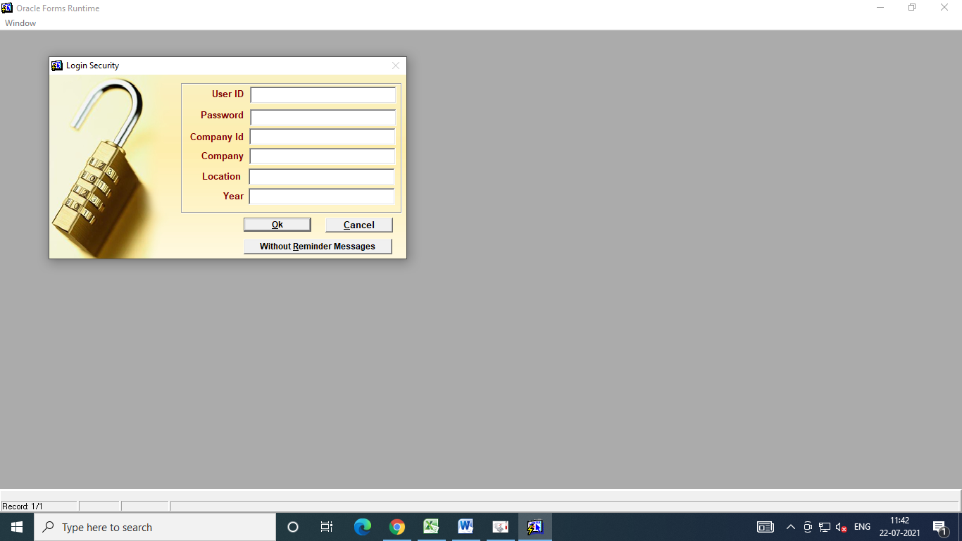
5.10.4 | Enter User ID and press Tab. Then enter the password. The screen will be seen as below :-
 | 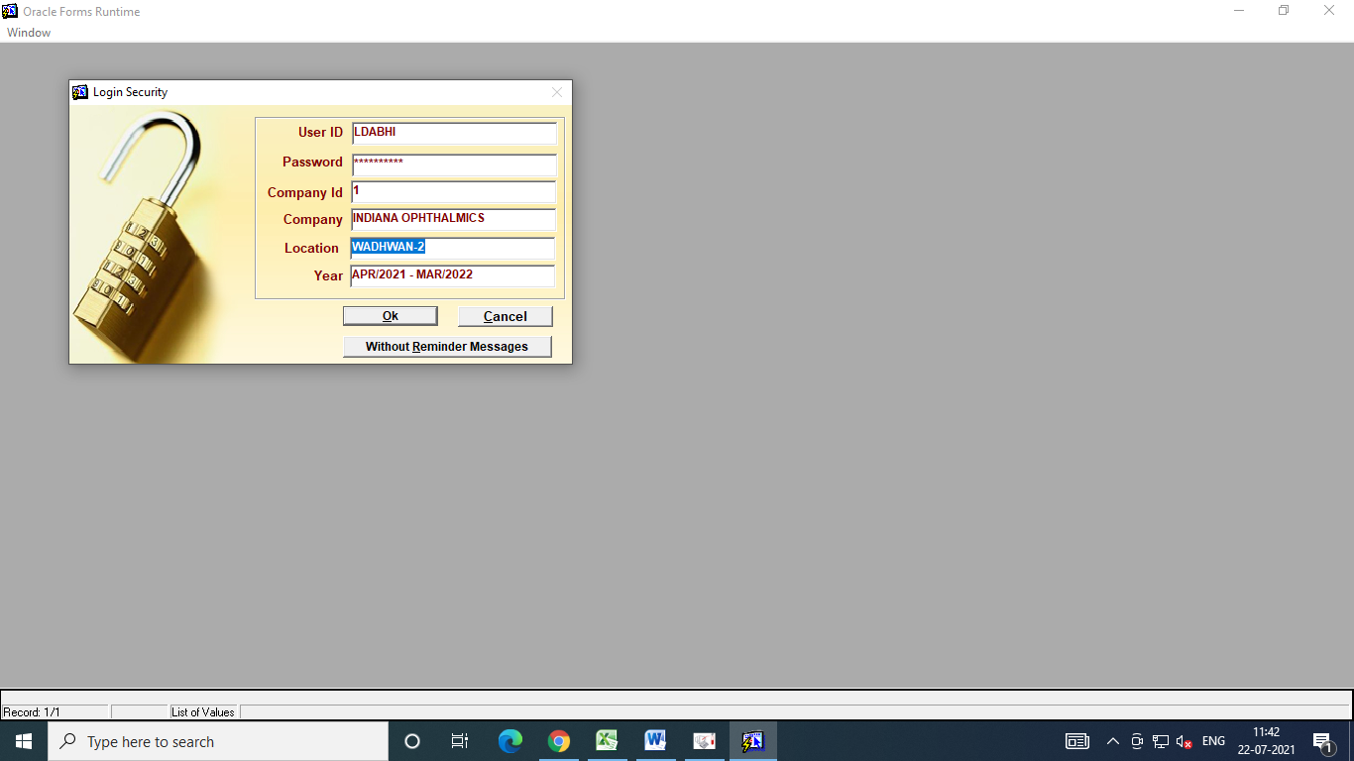
5.10.5 | Click on “OK”. The Screen will be seen as below :-
 | 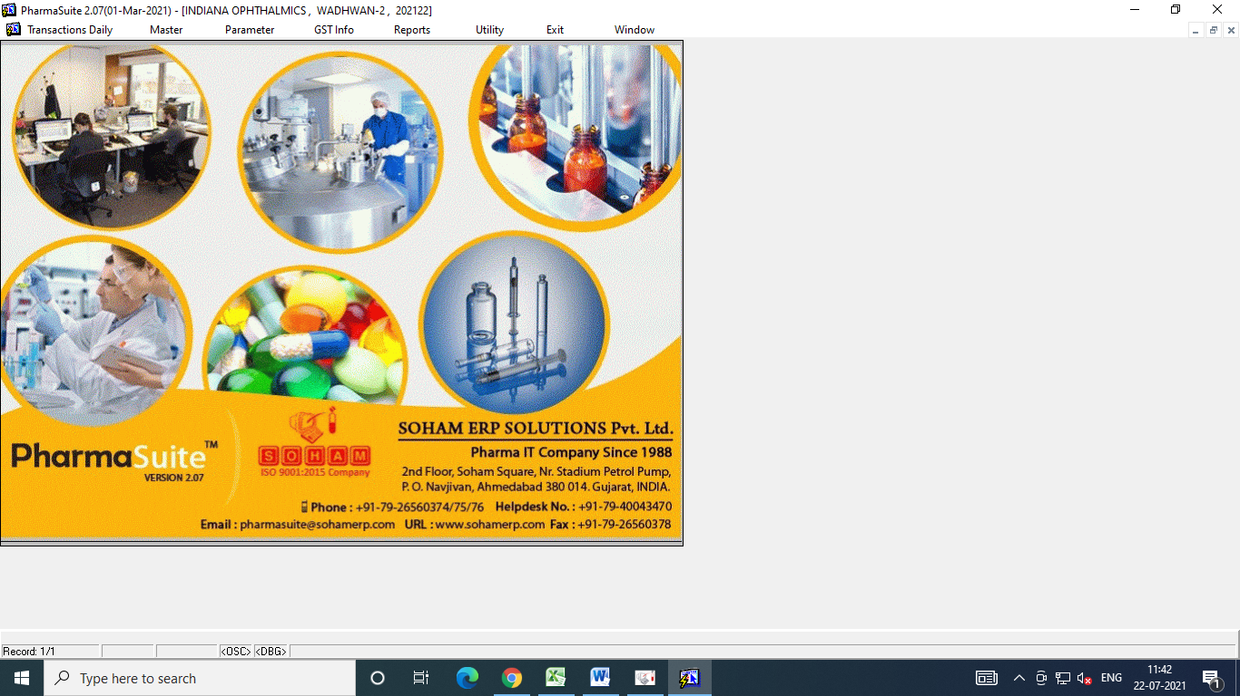
5.10.6 | Then Click on “Utility” and then Click on “Backup”.
 | 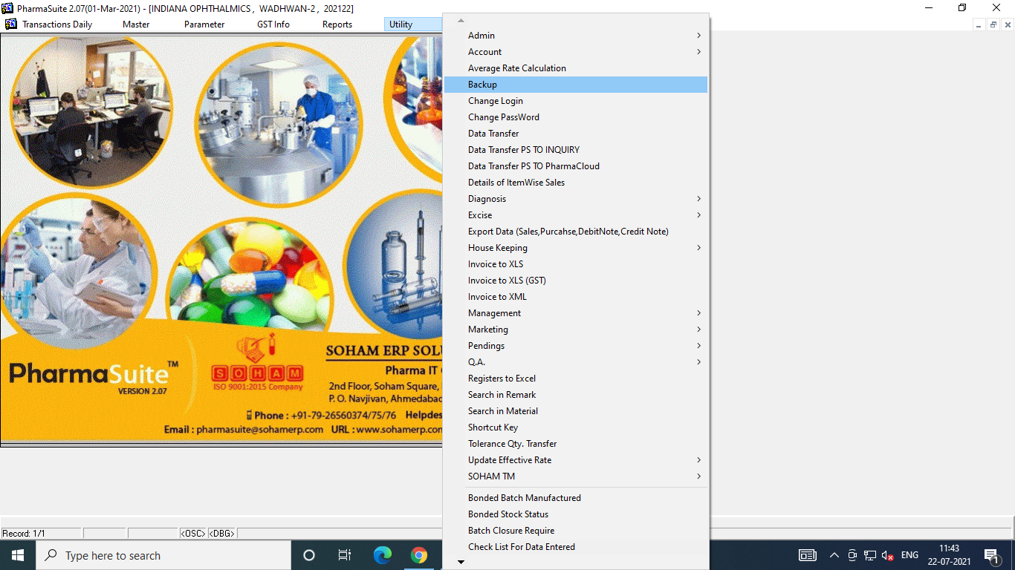
5.10.7 | The Screen will be seen as below :-
 | 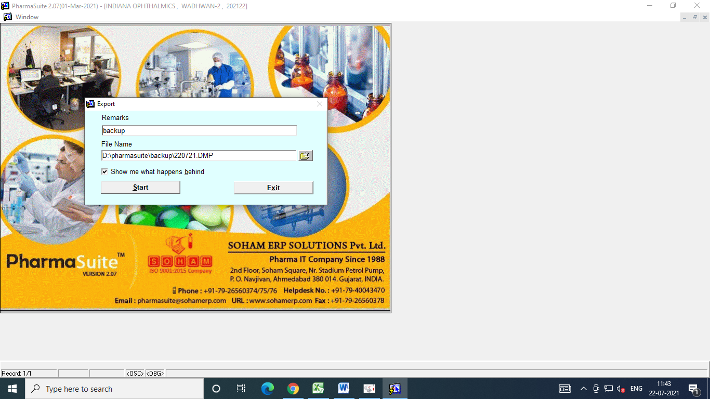
5.10.8 | Enter backup in the “Remarks” section and Select the “File Name” for data backup. Then click on “Start” to initiate the Backup activity. The Data will be backed up in the selected Location.
5.10.9 | Data backup is generated in a way that it backups all the data from starting date of back up to the current date, i.e., all the data till the date will be backed up.
5.10.10 | As a secondary data back-up, Administrator of Pharmasuite (ERP) shall take manual back up everyday morning (± 1 day) at time 09:00 hrs. (± 30 minutes) in external storage device. This external device shall be stored in lock and key area which can be accessible to the Administrator of Pharmasuite (ERP) only.
5.10.11 | Administrator of Pharmasuite (ERP) shall record the data backup activity as per Annexure-I (Data Back-up Record). The backup activity shall be verified by QA personnel.
5.10.12 | Restoration procedure shall be followed for Natural disaster, Hardware failure, Cyber Crimes, etc.
5.10.13 | For server reinstallation purpose, Pharmasuite server engineer shall use last backup taken either from server backup data or from cloud server drive backup data.
5.10.14 | The restoration procedure should be done at every six month (± 7 days) to periodically verify that the back-up has been done successfully. The activity of data restoration shall be recorded as per Annexure-II (Data Restoration Record). Data restoration shall be done by Administrator of Pharmasuite (ERP) and shall be verified QA personnel.
5.11 | Level of Authority :-
5.11.1 | Three levels of authority as described below shall be assigned at the time of user creation :-
Type of Level | Access Authorization
User Level | - Shall access the Pharmasuite (ERP) menu as per authority given by Administrator of Pharmasuite (ERP) on the request of respective department head based on the working area of user.  - Shall have access for the addition of data under authorized menu.
Supervisory Level | - Shall have authority for editing, review and monitoring of whole process of the respective department.
Administrator Level | - Shall have the authority for addition, deletion, modification and access of the full system and network.

5.12 | User Creation, User Deactivation and Privileges :-
5.12.1 | Administrator of Pharmasuite (ERP) shall have the authority for full access of the system and network.
5.12.2 | Administrator of Pharmasuite (ERP) shall only have the authority for user creation and providing user privileges.
5.12.3 | Respective department head shall forward the request as per Annexure-III (User ID Creation / Deletion Form) to the Administrator of Pharmasuite (ERP) in order to create or delete the user credentials.
5.12.4 | On receiving the request, Administrator of Pharmasuite (ERP) shall create the account login username and password of the new user or shall delete the account of the existing user.
5.12.5 | Administrator of Pharmasuite (ERP) shall maintain the list of users and level of authority as per Annexure-IV (List of Users and Level of Authority).
5.12.6 | After providing the user access, privileges shall be given to the user as per requirement of working area of the user or as per suggested by the department head.
5.12.7 | User shall be trained as per working area by the respective department head on the usage of Pharmasuite (ERP). Training Attendance Record as per annexure-III of SOP No. PEGE18 shall be maintained.
5.13 | Disaster Management and Recovery :-
5.13.1 | Observation and Reporting of Failure :-
5.13.1.1 | The user who observes the computer system failure shall inform to Department Head.
5.13.1.2 | The Department Head shall inform to Administrator of Pharmasuite (ERP) and to QA department.
5.13.2 | Assessment on Source and Impact :-
5.13.2.1 | Administrator of Pharmasuite (ERP), QA department and user department jointly shall make an assessment on the source and impact of the problem.
5.13.2.2 | If the source and impact are obvious, maintenance department shall document the source and impact as per Annexure-V (Disaster Recovery Form).
5.13.2.3 | If the source and impact are not obvious, maintenance department shall intimate to service provider and vendors to assess and fix the problem.
5.13.3 | Recovery and Corrective Actions :-
5.13.3.1 | Based on the evaluation result of source and impact, corrective actions shall be assessed jointly by Administrator of Pharmasuite (ERP), QA head, respective department head and maintenance head.
5.13.3.2 | If required, Administrator of Pharmasuite (ERP) shall make a proposal for system recovery to the Pharmasuite engineer and shall take necessary corrective actions.
5.13.3.3 | Administrator of Pharmasuite (ERP) in consultation with QA department and user department, shall make an assessment on preventive action plan that is required to prevent re-occurrence of the same or similar problems on the same or similar systems. A CAPA shall be registered as per SOP No. QAGE124 (Corrective and Preventive Action).
5.13.3.4 | After completion of recovery, corrective actions and preventive actions, system shall be released for usage. Prior-approval of QA Head is required as per Annexure-V for re-using the system.
5.13.4 | Disaster Prevention :-
5.13.4.1 | Disaster prevention for software backup and data :-
5.13.4.1.1 | Secondary data backup should be kept separate from the computer system in different place with lock and key.
5.13.4.1.2 | Backup media should be physically secured and protected from fire, water and other hazards.
5.13.4.2 | Disaster prevention against software loss :-
5.13.4.2.1 | Restore the software from recent backup. If restoration is not possible then re-install the software.
5.13.4.3 | Disaster prevention in case of backup failure :-
5.13.4.3.1 | Restart backup procedure immediately if failure of back-up has found. Record the activity in the data-backup record as per annexure-I.
5.14 | Pharmasuite (ERP) Server System Password Policy :-
5.14.1 | Administrator of Pharmasuite (ERP) shall possess the full authorization for the access of the server system.
5.14.2 | Addition of new system, deletion of existing system or modification in existing system into the network drive shall be authorized only by the Administrator of Pharmasuite (ERP).
5.14.3 | Password policy of the server system contains following parameters :-  - Enforce password history :- 03 passwords remembered,  - Maximum password age :- 45 days,  - Minimum password age :- 0 days,  - Minimum password length :- 7 characters,  - Password must meet the complexity requirement (combination of Alphabetical and numerical).
5.14.4 | Account lockout policy of server system includes :-
- Account lockout duration as 10 minutes,
- Account lockout threshold as 5 invalid logon attempts and
- Reset account lockout counter after 10 minutes.
5.15 | Server Security Policy :-
5.15.1 | Physical security of the server in case of emergency :-
5.15.1.1 | In case of emergency at the server locations, Administrator of Pharmasuite (ERP) shall have full authority to change any policy regarding the access to server.
5.15.2 | Logical security of the server :-
5.15.2.1 | Authorized Management personnel shall have the authority to use administrative login credentials for logging into all accounts, storage devices and network devices.
5.15.2.2 | Antivirus application is preventing all corruption of application or data by viruses or other agents.
5.15.2.3 | Environmental condition i.e., Temperature (NMT 30 ⁰C) and % RH (NMT 75%) of the server room shall be recorded twice in a day by using calibrated digital thermo hygrometer as per Annexure-III of SOP No. QAGE103.
5.16 | Pharmasuite (ERP) System Password Policy :-
5.16.1 | Administrator of Pharmasuite (ERP) has the authority for modifying the password of all the users.
5.16.2 | Password policy for software system shall include following criteria :-
 | - The password shall be minimum of 6 characters, shall not contain blank character and shall not be different from last 3 password,
 | - The password shall contain combination of alphabetical and numerical complexity,
 | - On 3 wrong password attempts, the user account will be locked,
 | - Account log in required after 10 minutes of inactivity,
 | - For locked user account, user shall intimate to Administrator of Pharmasuite (ERP) for creating new password,
 | - Administrator of Pharmasuite (ERP) shall reset password and create new password,
 | - Maximum password age is 365 days. After 365 days, password shall be reset.
 | - Administrator of Pharmasuite (ERP) can change the policies of password at any time subject to the intimation from management.
5.16.3 | If there is a need of change of password by any user (for example, due to 03 wrong password attempts or any other reason), user shall intimate to Administrator of Pharmasuite (ERP).
5.16.4 | Administrator of Pharmasuite (ERP) shall reset the password if found necessary by entering the necessary details in Annexure-VI (List of User ID and Password).
5.17 | Operational Procedure :-
5.17.1 | User shall double click on the symbol  to open the Pharmasuite. The screen will be seen as below :-
 | 
5.17.2 | Enter User ID, then press Tab. Then enter the password and press OK. The screen will be seen as below :-
 | 
5.17.3 | Select year as per requirement of work and click on “OK”. The screen will be seen as below :-
 | 
5.17.4 | Open the menu related to work as per user privileges and perform the task.
5.17.5 | The list of application department alongwith their operational activities are described below :-
5.17.5.1 | Quality Assurance Department :-
5.17.5.1.1 | Following are the activities on routing basis done in Pharmasuite (ERP) by QA Department.
Sr. No. | Activities
1 | Pack Product Release
2 | Material Wise Approved Vendors
3 | Retain Sample Collection

5.17.5.1.2 | Following masters shall be updated by QA Department :-
Sr. No. | Activities | Sr. No. | Activities
1 | Raw Material Master | 10 | Process Master
2 | Packing Material Master | 11 | Object Type Master
3 | Product Master | 12 | Manufacture Master
4 | UOM Master | 13 | Manufacture License Master
5 | Manufacture License Master | 14 | Made of Master
6 | Therapeutic Category Master | 15 | Item Sub Type Master
7 | Storage Condition | 16 | Formula Master
8 | Pack Master | 17 | Conversion Master
9 | Specification Master | 18 | Abbreviation Master

5.17.5.2 | Quality Control Department :-
5.17.5.2.1 | Following are the activities on routing basis done in Pharmasuite (ERP) by Quality Control Department.
Sr. No. | Activities | Sr. No. | Activities
1 | Test Description Master | 9 | Sample Receiving For In Process Testing
2 | Issue for Testing | 10 | Sample Outside testing Slip
3 | Sample Testing Protocol | 11 | Sample Receiving for product testing
4 | Sample analysis Report | 12 | Sample Receiving for product retesting
5 | Material Analysis Report | 13 | Sample outside Analytical Rep. Received
6 | Product Analysis Report | 14 | Sample Test Request
7 | In Process Analysis Report | 15 | Sample Requisition
8 | Sample Receiving For Material Testing

5.17.5.3 | Production Department :-
5.17.5.3.1 | Following are the activities on routing basis done in Pharmasuite (ERP) by Production Department.
Sr. No. | Activities | Sr. No. | Activities
1 | Batch Creation | 6 | Transfer from Production
2 | Material Requisition Slip | 7 | Sample Collection
3 | In Process Test Request | 8 | Dispensing For Mfg.
4 | Product Test Request | 9 | Production Slip
5 | Bonding Slip | 10 | Return from Manufacturing

5.17.5.4 | Warehouse Department :-
5.17.5.4.1 | Following are the activities on routing basis done in Pharmasuite (ERP) by Production Department.
Sr. No. | Activities | Sr. No. | Activities
1 | Good Receiving | 7 | Inward
2 | Dispensing for Mfg. | 8 | Opening Stock
3 | Issue For Consumption | 9 | Issue for Other Work
4 | Material Loss / Destroy | 10 | Material Sales / Purchase Return
5 | Reclassification of Material | 11 | Storage Bin Assignment
6 | Excess Found | 12 | Goods Outward at Gate

5.17.5.5 | Purchase Department :-
5.17.5.5.1 | Following are the activities on routing basis done in Pharmasuite (ERP) by Purchase Department.
Sr. No. | Activities
1 | Purchase Requisition
2 | Purchase Order / Work Order (GST)
3 | Goods outward at Gate
4 | Purchase Order Closure

5.17.5.6 | Sales Department :-
5.17.5.6.1 | Following are the activities on routing basis done in Pharmasuite (ERP) by Sales Department.
Sr. No. | Activities | Sr. No. | Activities
1 | Sales Order | 5 | Credit Note (With Qty. Effect)
2 | Sales Order (GST) | 6 | Sales Return
3 | Delivery Challan | 7 | Purchase Finished Goods (GST)
4 | GST Sales Invoice | 8 | Finished Goods Purchase Order

6.0 | ANNEXURES:-
6.1 | Annexure-I : Data Backup Record
6.2 | Annexure-II : Data Restoration Record
6.3 | Annexure-III : User ID Creation / Deletion Form
6.4 | Annexure-IV : List of Users and Level of Authority
6.5 | Annexure-V : Disaster Recovery Form
6.6 | Annexure-VI : List of User ID and Password
7.0 | REFERENCES:- NA
8.0 | REVISION HISTORY:-
Sr.  No. | Revision No. | Date of Revision | SOP No. | Supersedes No. | Reason for Revision
 | 01 | 30/12/2022 | QAGE131-01 | QAGE131-0 | - Change in Firm Name from “Indiana Ophthalmics” to “Indiana Ophthalmics LLP”.  - Addition of Scope, Annexures, References and Revision History as Section 2.0, 6.0, 7.0 and 8.0 respectively in the SOP.

